Getting Started Using Spreadsheets

**The Basics of Formulas**

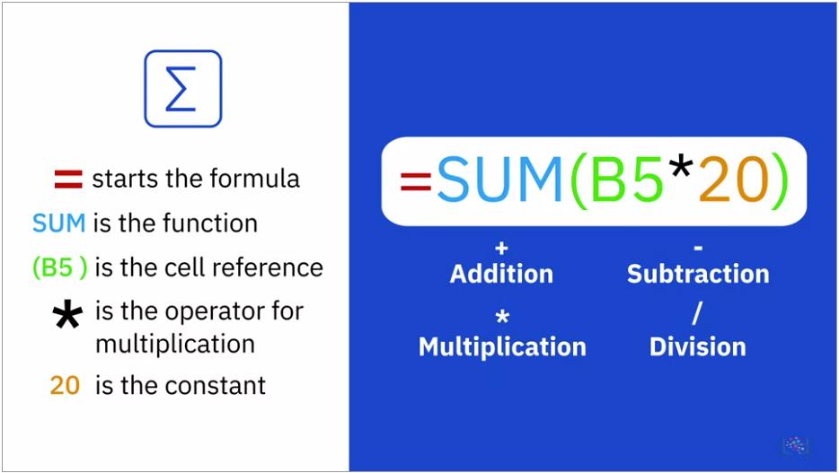

**Referencing Data in Formulas**

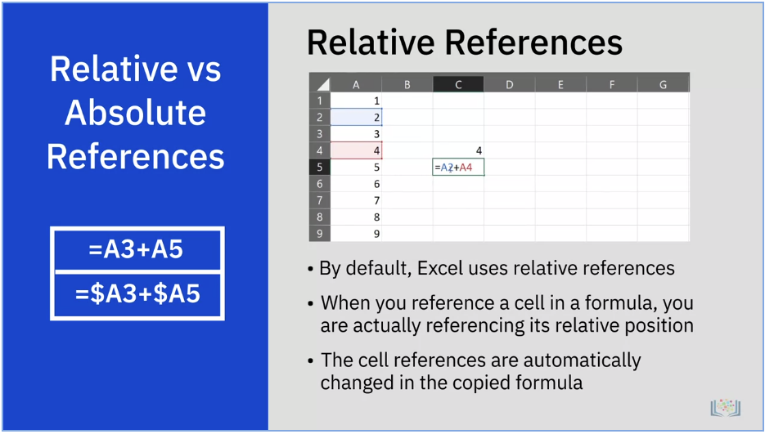

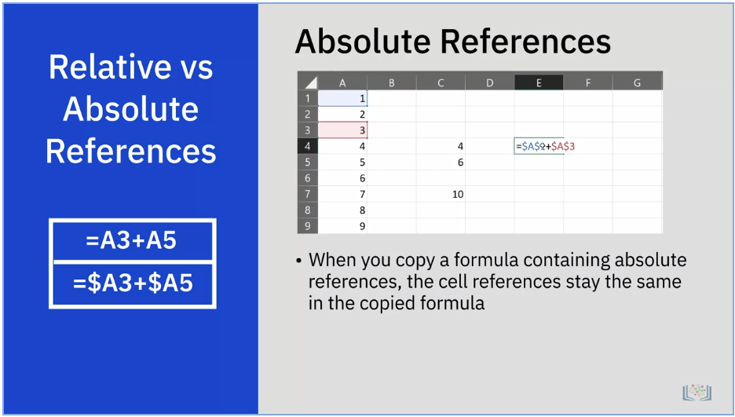

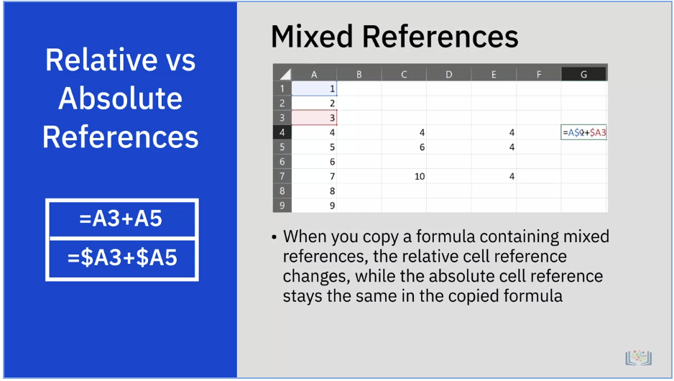

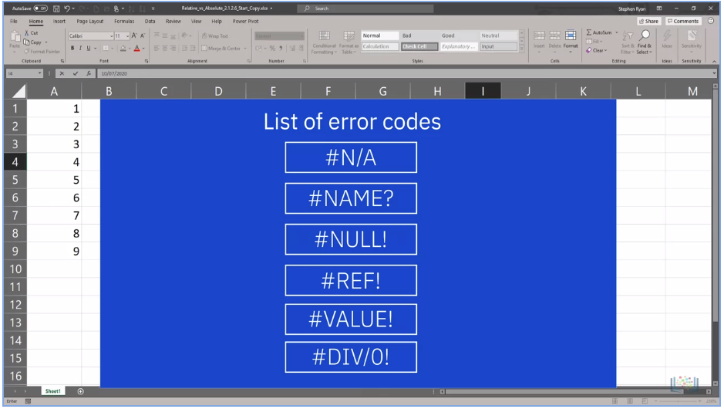

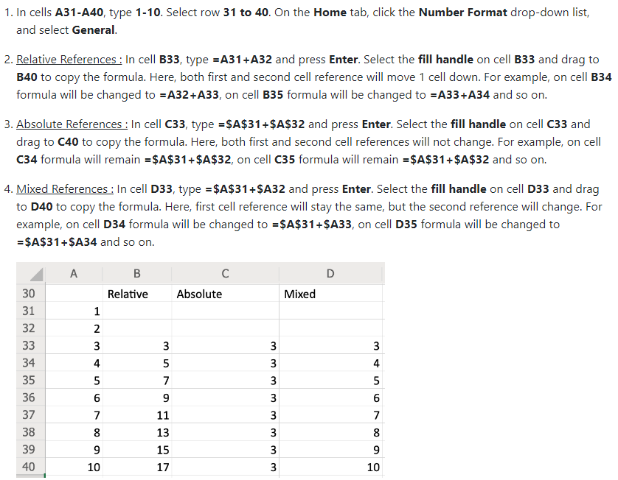

**Summary and Highlights**

In this lesson, you have learned:

* There are several features to modify views in Excel, and it is very straightforward to enter and edit data in a spreadsheet.
* You can move or copy data within a worksheet or between worksheets, and you can use AutoFill to automatically enter data that is in a series or that fits a pattern.
* You can format both cells and data in Excel.
* A formula is made up of several component parts, and formulas can perform calculations using numbers directly or by using references to data in the worksheet.
* You can use the Fill Handle in Excel to quickly copy formulas to other cells.
* There are several different categories of function you can use for different purposes, and you can search for a function by name, or by category.
* You can reference cells in the worksheet in your formulas by using relative, absolute, or mixed references.
* You can make a formula absolute by adding a dollar symbol ($) to a cell reference.
* If you get errors in your formulas, you can use the error-checking capabilities of Excel to resolve them.